Northland Pines Cross Country Invitational Meet
Tuesday, Oct 3, 2017

Dear Coaches & A.D.’s: Welcome to the Northland Pines Cross Country Invitational!!

On Tuesday, Oct 3rd, 2017 Northland Pines will host a High School Boys & Girls, and Middle School Cross Country meet at Northland Pines High School.

Participating Schools: Antigo, Florence, Mercer, Northland Pines, Rhinelander, Three Lakes, & Tomahawk.

Course Distances: Middle School—2500 meters Girls HS—5000 meters Boys—5000 meters

Course Maps: Maps are included as an attachment.
Middle School = Purple Course Boys HS & Girls HS = Red Course
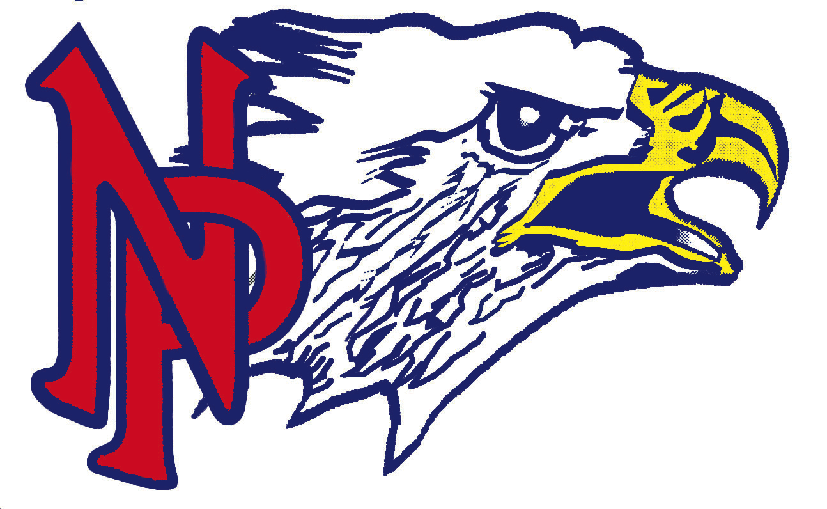
Order of Races: 2:45 p.m. Course opens for running/viewing
3:45 p.m. Coaches meeting at Start/Finish area
4:00 p.m. Middle School Coed Race
4:30 p.m. Girls High School Race
5:10 p.m. Boys High School Race
* Lane assignments will be assigned in alphabetical order.
(Antigo, Florence, Mercer, Northland Pines, Rhinelander, Three Lakes, & Tomahawk)

Awards: Team Awards for first place Boys’ HS & first place Girls’ HS teams. (Insert team award for MS boys’ & girls’ if desired.) Medals to top 10 HS Boys & 10 HS Girls, and top 5 MS Boys & 5 MS Girls.

Entries: The HS Boys’ & Girls’ races are Open Races so no separation of Varsity or JV is necessary. Itiming will be timing the race and used for scoring and results. A list of runners for boys, girls, and middle school must be emailed using the attached Excel spreadsheet format to Itiming.com, by 8:00 pm, Sunday, 10/1/2017. Last minute changes should be done onsite with Itiming.

Fees: Please send your entry fee of $100 for each school to Wendy Pluedeman @ NPHS Activities, 1800 Pleasure Island Rd., Eagle River, WI 54521.

Note: This course has been setup in cooperation with the Eagle River Golf Course. Remain off greens & tees.

For any questions, please contact the following listed below.

Brian Margelofsky Don Czarapata Jr.
Northland Pines A.D. CC Coach
715-891-0709 (Cell) 715-892-7483 (Cell)
715-479-6286 (Office)

Thank-you & I’ll see your athletes on Tuesday, October 3rd.

Brian Margelofsky
Activities Director
Northland Pines H.S.

